
PREDICTIVE MONITORING SYSTEM FOR
COAL DELIVERY VESSEL

PROJECT REPORT

Angga Pratama Suryabrata (2506565654)
Rina Widyasti Habibah (2506566240)
Putri Nur Meilisa (2506566190)

JURUSAN REKAYASA DATA DAN BISNIS INTELEJENSIA
FAKULTAS TEKNIK ELEKTRO
UNIVERSITAS INDONESIA
2025

Introduction
  - Background
PT PT Bahtera Adhiguna (PT. BAg) is a national shipping company and a subsidiary of PT PLN (Persero) through PLN Energi Primer Indonesia, which operates in the field of coal and primary energy transportation to support the electricity supply of PT PLN and its partners. Up to 40% of the cost in PT BAg is used for fuel consumption for 16 vessels. Currently, the vessel utilizes a combination of manual and digital fuel measurement systems. As is condition system is a software-as-a-service (SaaS) combined with Satellite data subscription using Iridium Satellite, which makes PT BAg reliant on a 3rd party system. The mixed system of measurement methods imposes limitations on data accuracy, speed, and cost-effectiveness.
  - Problem Statement
The Project Addresses this Challenge
- Around 40% PT Bag cost spent on Fuel for ship, currently monitoring the fuel usage in the ship using manual system, record on ship log
- Ship Arrival to customer also one of the key performance measurements. Delay can cause penalty
- Predicting both fuel usage and ship arrival is important, but takes time since it should read and evaluated from ship log
- Delayed Reporting happens, since using ship log sent to headquarter
  - Objectives
Business Objective are to improve vessel operational efficiency by leveraging data -driven insights.
Technical Objectives are The change from the current state (As-Is) to the desired state (To-Be) is defined as follows:
- Automatic Measurement of fuel inventory in the tank.
- Automatic Measurement of fuel consumption in the Auxiliary Engine (AE) and Main Engine (ME).
- Integration of manual measurement readings into the Fuel Management System (FMS) application.
- Predictive fuel consumption and Estimated Time of Arrival (ETA).
  - Success Criteria
The Project Considered success following these criteria:
- Estimated Time Arrival Predicted in > 95% of time
- Real-time data latency < 1 minutes
- System uptime > 95#
- The Project Satisfy Audits findings

Project Management
  - Project Timeline
Sprint | Duration | Phase | Key Activities | PIC
1 | W1-W2 Sept 2025 | Initiation | Stakeholder Interviews | PNM, RWH
2 | W3-W4 Sept 2025 | Initiation | Requirements Gathering | PNM, RWH
3 | W1-W2 Okt 2025 | Analysis & Design | UML Diagram, Architecture Diagram, Database Schema | PNM, RWH,  APS
4 | W3-W4 Okt 2025 | Analysis & Design | Backend API, MQTT setup, Database implementation | PNM, RWH,  APS
5 | W1-W2 Nov 2025 | Development Sprint 1 | Frontend | RWH,  APS
6 | W3-W4 Nov 2025 | Development Sprint 2 | Backend API | RWH,  APS
7 | W1-W2 Des 2025 | Development Sprint 3 | MQTT setup, Database Implementation | RWH,  APS
 | W3-W4 Des 2025 | Holiday
8 | W1-W2 Jan 2026 | Development Sprint 4 | ML Service & Model Training | RWH,  APS
9 | W3-W4 Jan 2026 | Testing & QA | Integration Testing, UAT, Performance Testing | PNM, RWH
10 | W1-W2 Feb 2026 | Deployment | Production Deployment | PNM, RWH
  - Project Person in Charge
Project Person in Charge:
- Angga Pratama Suryabrata (APS)
- Rina Widyasti Habibah (RWH)
- Putri Nur Meilisa (PNM)

  - Requirements Analysis (problem statement)
The Project Addresses this Challenge
- Around 40% PT Bag cost spent on Fuel for ship, currently monitoring the fuel usage in the ship using manual system, record on ship log
- Ship Arrival to customer also one of the key performance measurements. Delay can cause penalty
- Predicting both fuel usage and ship arrival is important, but takes time since it should read and evaluated from ship log
- Delayed Reporting happens, since using ship log sent to headquarter

  - Scope
A Software Development Project consist of
- Central Applications with deliverables in
- On ship Edge Gateway Implementations
- Machine learning model for Fuel usage prediction and ETA arrival

  - Business modelling
The Predictive Monitoring System for PT Bahtera Adiguna (Bag) are to track real-time 15 minutes interval Ship monitoring with considering operational parameter such as fuel consumption engine load, vessel speed, route and sea state.
Value Proposed by team are to provide actionable insights for Bag as ship Operators to optimize route planning and fuel cost. Ultimately improving profitability and sustainability. Using 2 predictive functions: Ship fuel consumptions and Estimated Time of Arrival. The project aiming to improve vessel operational efficiency by leveraging data-driven insights

Business Model for this project are Business to business Application development project that consist of Developing Software and implementing IoT systems on ships

  - Risk Register
Risk Category | Risk Description | Probability | Impact | Mitigation Strategy
Technical | LSTM model accuracy below target | Medium | High | Hyperparameter tuning as Supporting Service in Post Production
Technical | MQTT connectivity loss at sea | High | Medium | Local buffering, retry logic
Technical | Sensor calibration drift | Medium | Medium | Periodic Calibration schedule,  redundant Sensors
Operational | User adoption resistance | Medium | High | Comprehensive training, change management program
Operational | Data Quality issues | High | High | Validation Rules, Anomaly Detections
Project | Timeline Delays | Medium | Medium | Prioritization
External | External Integrations  (etc Weather API) | Low | Medium | Caching and choose Services with High Uptime SLA
Security | Unauthorized access | Low | High | Implement Tight Security Configurations (Authentication, Encryption) Implement Audit logging

  - Stakeholder Analysis
Stakeholder | Interest | Influence | Engagement Strategy | Communication Frequency
Planning Department  (Bag HQ) | High | High | Maintain Close Relations | Bi weekly Report and Daily Communications
Ship Captains | High | medium | Request Feedback | Per -requested. Taking notes on feedback
Operational Department – Fleet Management  (HQ) | High | High | Maintain Close Relations | Bi weekly Report and Daily Communications
IT Department | Medium | High | Maintain Close Relations | Bi weekly Report and Daily Communications
Regulatory Bodies | Low | Medium | Maintain Compliance | Per – needed basis
  - RACI Matrix
Activity / Role | Responsible (R) | Accountable (A) | Consulted (C) | Informed (I)
Project planning | Project Manager | Board of Directors | User, Finance | All stakeholders
Needs analysis | Technical Team, User | Project Manager | Directors | PR Team
System / solution design | Technical Team | Project Manager | User | Directors
Implementation | Technical Team, Vendor | Project Manager | User | Finance
Evaluation & reporting | Project Manager | Board of Directors | User, Vendor | All stakeholders

Design
  - Core Features
    - Route Visualization
- Interactive Map
- Dual – Line Rendering
  - Solid green line: traversed path
  - Dotted gray line: remaining route
- Weather overlay: Real-time weather conditions along route
    - Real-Time Fuel Monitoring
Dashboard – a Live Fuel level visualization for entire fleet
Alerts – Threshold-based notifications for low fuel levels
Historical Trends: 30 – day fuel consumptions patterns
Sensor Health: Status monitoring for IoT Device (connected/disconnect/Unavailable)
    - ETA – Prediction (Supervised Machine Learning Based
Input Features:
- Historical voyage data (AIS)
- Current Location & Speed
- Weather conditions along route
- Sea current data
- Vessel characteristic (draft, tonnage)
    - Model Architecture:
- Bi-directional LSTM with attention mechanism
- Input sequence length: 24 hours historical data
- Output: ETA + - 5 to 10 % minutes with 95% confidence interval
  - Diagram
    - Use Case Diagram
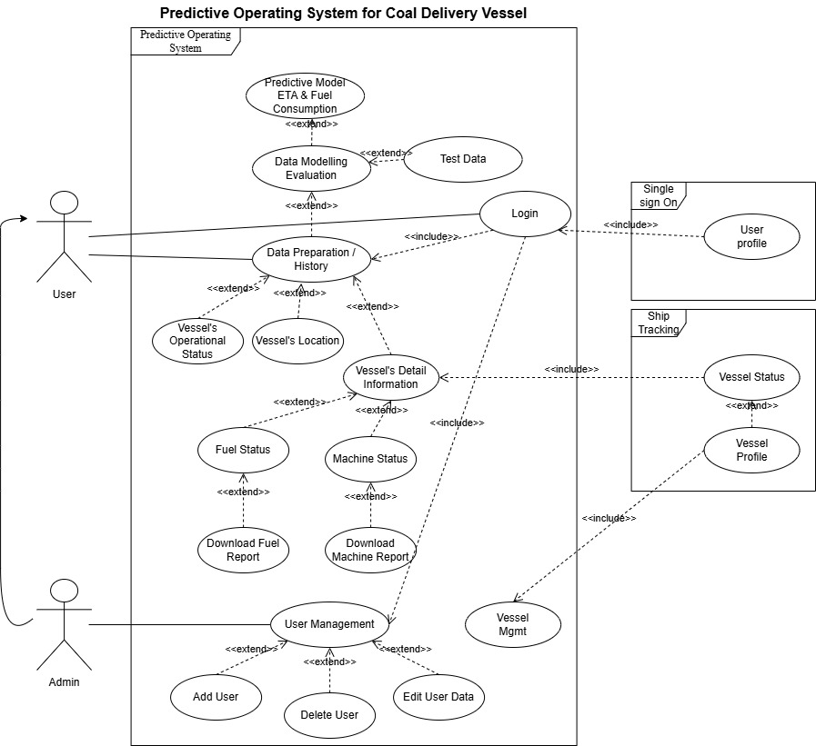
    - System Architecture Diagram
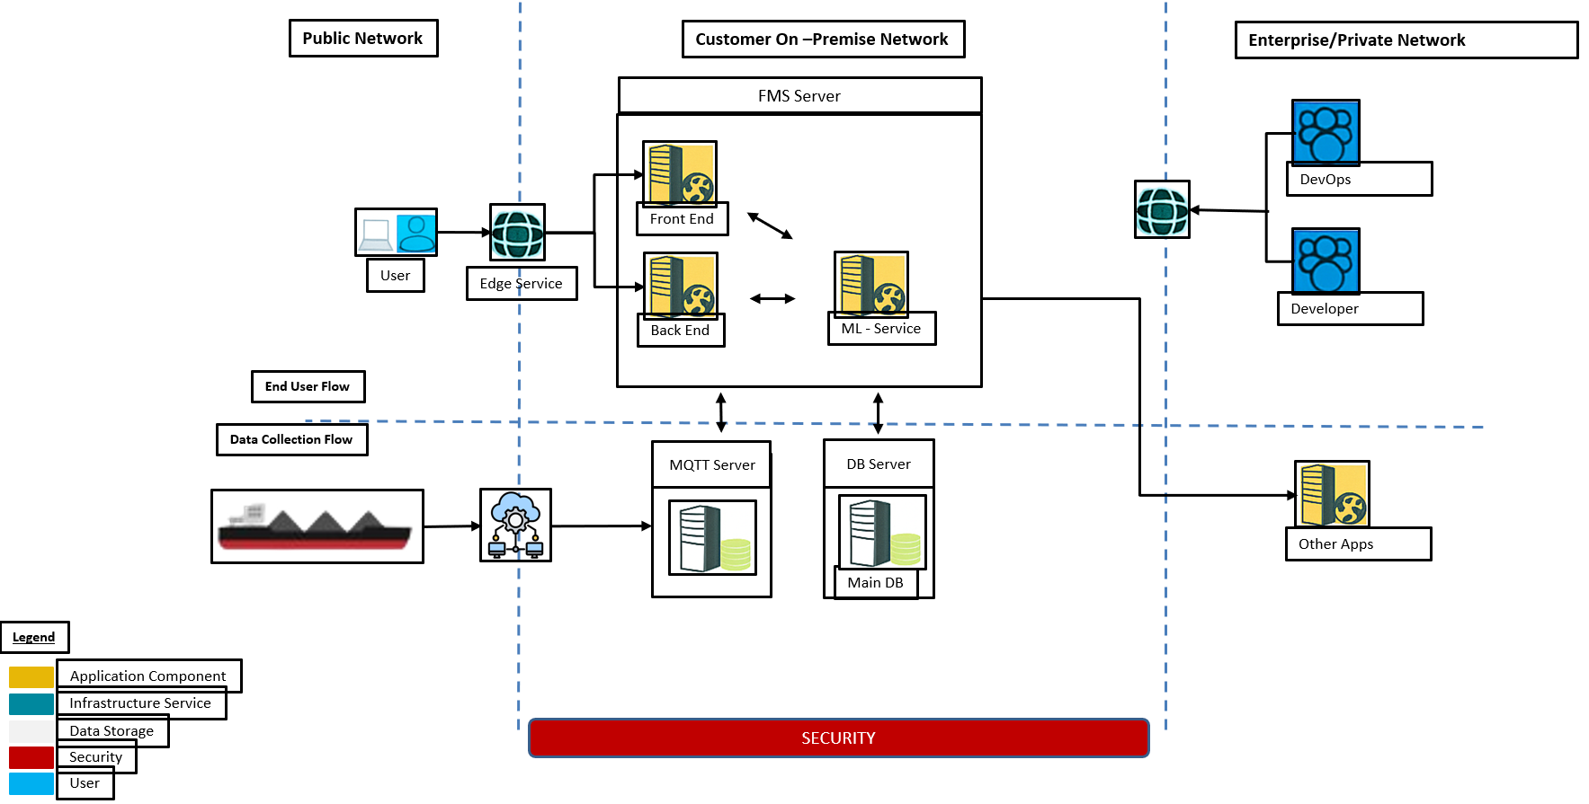

    - Class Diagram
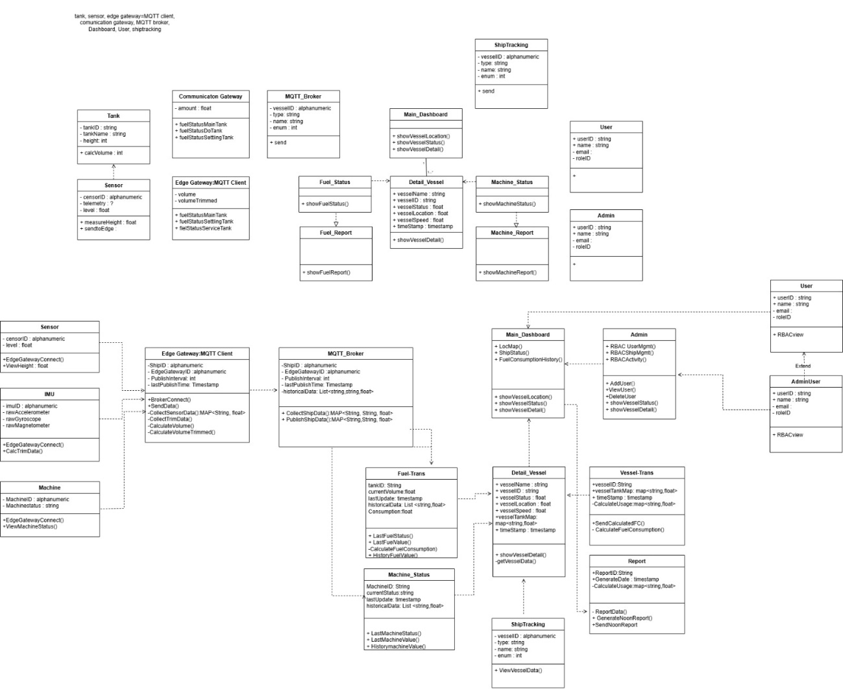
    - Sequence Diagram
      - ETA Prediction Flow (On Progress Research)
On Progress Research
      - Fuel Prediction Flow(On Progress Research)
On Progress Research
  - Technical Deliverables
- Frontend Application using Vue.js 3 + TypeScript + Tailwind CSS
- Backend API Go - RESTful architecture
- Machine Learning Service using Python + TensorFlow/Keras
- MQTT Infrastructure using Mosquitto broker + edge gateways
- Database Schema using PostgreSQL with TimescaleDB extension
- Infrastructure using Virtual Machine VMware and Kubernetes (On Premise Deployment
- API Documentation using OpenAPI/Swagger

  - Document Deliverables
- User Manual
- Technical Documentation

  - Software Function Deliverables
Priority | Module | Feature | Description | Deliverables
 | Application > Central Application on Shipping Company Private Cloud with Public Access
Must | Auth & RBAC | Login & Role-based Read-only | View access based on roles (NOC Operator, Fleet Manager, Auditor) with no write actions. | Concise User Manual
Must | UI Frame | UI Kit | Translate Figma to Usable UI (Button, Frame, Panel, Data List, ) | Wireframes & Mockups
Must | Fleet Map | Fleet Map & Status | Vessel clustering, status colors (normal/low fuel/offline), search and filters. | View/Data Model
Must | Vessel Dashboard | Tank Cards | Height (mm), Volume (m³), Capacity %, last update timestamp per tank. | Lightweight Design System
Must | Trends & History | 24h/7d Charts | Zoom/pan with toggleable series (height/volume). | View/Data Model
Must | Alert Center | Alert History (View-only) | List & filter alerts by severity/type/time/vessel. | Wireframes & Mockups
Must | Export | Report Export | Export CSV/PDF for fleet/vessel snapshot over selected period. | Concise User Manual
Must | UI/Performance | Auto-Refresh & Loading Indicators | Default 15-second auto-refresh, manual refresh button, loading indicators. | Wireframes & Mockups
Should | Calibration Viewer | Calibration Curve Overlay (Read-only) | Show height→volume curve as a reference on the chart. | Lightweight Design System
Should | Geofence | Port/Route Overlay | Display geofences on the map (view-only). | UI & E2E Test Plan
Should | Analytics Widgets | Top-N Vessels | Widget for vessels with lowest fuel / most frequently offline. | Lightweight Design System
Should | Analytics | Speed Prediction Widget (Read-only) | Displays short-horizon speed forecast (e.g., next 2–6 hours) based on recent GPS time-series; UI consumes prediction API. | UI & E2E Test Plan
Could | UI Frame | Dark Mode / PWA | Dark theme and installable app (optional). | Lightweight Design System
 | Ship > Tailored Configuration for Each Ship
Must | AssetSensor | Asset Unique ID, List & Connection | Recognize Sensor and Unique ID Sensor, Data and Attribute | API Integration Spec (Read-only)
Must | AssetTank | Asset Unique ID, Tank Information | Tank ID and Tank VOlume Calculation | API Integration Spec (Read-only)
Must | VolCalc | Volume Calculation | Calculate Level Sensor to Volume Table to get Volume | API Integration Spec (Read-only)
Must | TrimCalc | TrimmedCalculation | Calculate Volume based on Ship Current Trim | API Integration Spec (Read-only)
Must | Payload | Payload send to Central System | Agreement to Central System for Payload | Concise User Manual
 | Project
 | Weekly | Weekly | Weekly
 | Daily | Daily | Daily
Must | Auth & RBAC | Positive & Negative Test | Automate Test Case and QA Using Positive and Negative Test for each Modul | UI & E2E Test Plan
Must | UI Frame | Positive & Negative Test | Automate Test Case and QA Using Positive and Negative Test for each Modul | UI & E2E Test Plan
Must | Fleet Map | Positive & Negative Test | Automate Test Case and QA Using Positive and Negative Test for each Modul | UI & E2E Test Plan
Must | Vessel Dashboard | Positive & Negative Test | Automate Test Case and QA Using Positive and Negative Test for each Modul | UI & E2E Test Plan
Must | Trends & History | Positive & Negative Test | Automate Test Case and QA Using Positive and Negative Test for each Modul | UI & E2E Test Plan
Must | Alert Center | Positive & Negative Test | Automate Test Case and QA Using Positive and Negative Test for each Modul | UI & E2E Test Plan
Must | Export | Positive & Negative Test | Automate Test Case and QA Using Positive and Negative Test for each Modul | UI & E2E Test Plan
Must | UI/Performance | Positive & Negative Test | Automate Test Case and QA Using Positive and Negative Test for each Modul | UI & E2E Test Plan
Should | Calibration Viewer | Positive & Negative Test | Automate Test Case and QA Using Positive and Negative Test for each Modul | UI & E2E Test Plan
Should | Geofence | Positive & Negative Test | Automate Test Case and QA Using Positive and Negative Test for each Modul | UI & E2E Test Plan
Should | Analytics Widgets | Positive & Negative Test | Automate Test Case and QA Using Positive and Negative Test for each Modul | UI & E2E Test Plan
Should | Analytics | Positive & Negative Test | Automate Test Case and QA Using Positive and Negative Test for each Modul | UI & E2E Test Plan
Could | UI Frame | Positive & Negative Test | Automate Test Case and QA Using Positive and Negative Test for each Modul | UI & E2E Test Plan
Must | Auth & RBAC | Documentation | Write Documentation | UI & E2E Test Plan
Must | UI Frame | Documentation | Write Documentation | UI & E2E Test Plan
Must | Fleet Map | Documentation | Write Documentation | UI & E2E Test Plan
Must | Vessel Dashboard | Documentation | Write Documentation | UI & E2E Test Plan
Must | Trends & History | Documentation | Write Documentation | UI & E2E Test Plan
Must | Alert Center | Documentation | Write Documentation | UI & E2E Test Plan
Must | Export | Documentation | Write Documentation | UI & E2E Test Plan
Must | UI/Performance | Documentation | Write Documentation | UI & E2E Test Plan
Should | Calibration Viewer | Documentation | Write Documentation | UI & E2E Test Plan
Should | Geofence | Documentation | Write Documentation | UI & E2E Test Plan
Should | Analytics Widgets | Documentation | Write Documentation | UI & E2E Test Plan
Should | Analytics | Documentation | Write Documentation | UI & E2E Test Plan
Could | UI Frame | Documentation | Write Documentation | UI & E2E Test Plan

  - Wireframe
Current Wireframe concept for main page
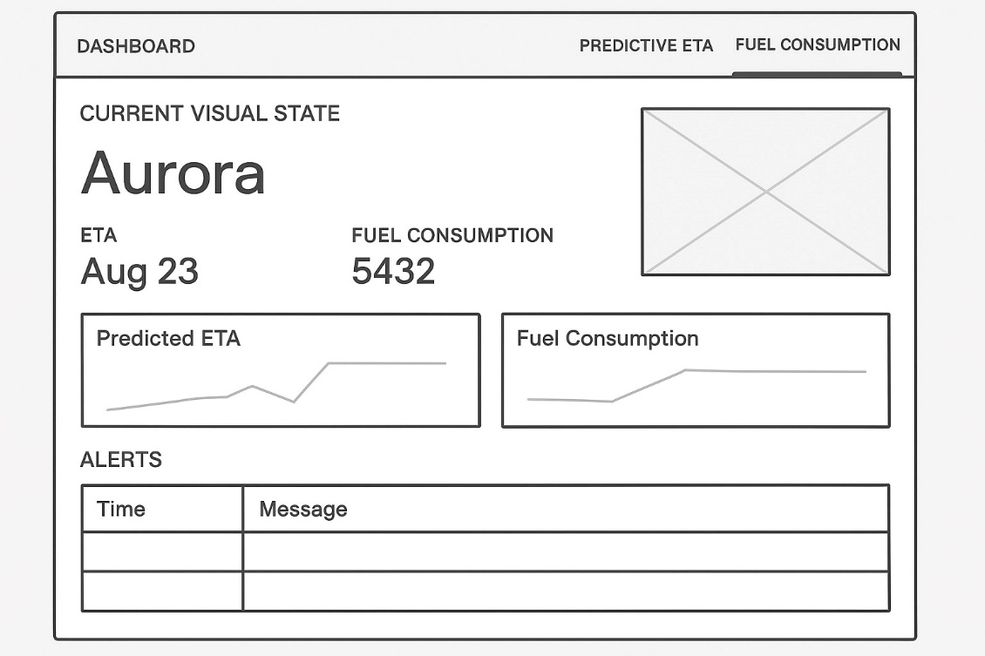

  - Software Testing Strategies
1. Unit Tests Using Positive and Negative Case
- Backend using Go testing framework
- Frontend using Vitest + Vue Test Utils
- ML Service Using pytest + unittest
- Functional (Menu Test ) Target :
- Target Function:
- - Auth & RBAC
- UI Frame
- Fleet Map
- Vessel Dashboard
- Trends & History
- Alert Center
- Export
- UI/Performance
- Calibration Viewer
- Geofence
- Analytics Widgets
- Analytics
- UI Frame

2. Integration Tests
- API endpoint testing using (Postman/Newman)
- MQTT message flow validation using Wireshark
- Database transaction integrity
- ML model inference pipeline using pytest

3. Performance Tests
- Load testing: 100 concurrent users using jmeter
- Stress testing: MQTT message throughput (1000 msg/s) using jmeter
- ML inference latency: < 500ms p95*

4. User Acceptance Testing (UAT)
- Scopes: 2-week pilot with 2 vessels
- Captain feedback sessions
- Fleet manager approval checklist
- Functional (Menu Test ) Target :
- Target Function:
- - Auth & RBAC
- UI Frame
- Fleet Map
- Vessel Dashboard
- Trends & History
- Alert Center
- Export
- UI/Performance
- Calibration Viewer
- Geofence
- Analytics Widgets
- Analytics
- UI Frame
5. Security Testing
- Penetration testing (OWASP Top 10)
- API authentication/authorization
- Data encryption verification

Current State Development (Progress)
  - Project State
Sprint | Duration | Phase | Key Activities | PIC | Status
1 | W1-W2 Sept 2025 | Initiation | Stakeholder Interviews | PNM, RWH | Completed
2 | W3-W4 Sept 2025 | Initiation | Requirements Gathering | PNM, RWH | Completed
3 | W1-W2 Okt 2025 | Analysis & Design | UML Diagram, Architecture Diagram, Database Schema | PNM, RWH,  APS | Completed
4 | W3-W4 Okt 2025 | Analysis & Design | Backend API, MQTT setup, Database implementation | PNM, RWH,  APS | Completed
5 | W1-W2 Nov 2025 | Development Sprint 1 | Frontend | RWH,  APS | Completed
6 | W3-W4 Nov 2025 | Development Sprint 2 | Backend API | RWH,  APS | In Progress
7 | W1-W2 Des 2025 | Development Sprint 3 | MQTT setup, Database Implementation | RWH,  APS | Backlog
 | W3-W4 Des 2025 | Holiday
8 | W1-W2 Jan 2026 | Development Sprint 4 | ML Service & Model Training | RWH,  APS | Backlog
9 | W3-W4 Jan 2026 | Testing & QA | Integration Testing, UAT, Performance Testing | PNM, RWH | Backlog
10 | W1-W2 Feb 2026 | Deployment | Production Deployment | PNM, RWH | Backlog

  - Issue list (Current Progress)
Current Issue on Development Sprint 2 are:
Issue | Action | Status
Additional feature  Prediction | Update UML:  initial diagram  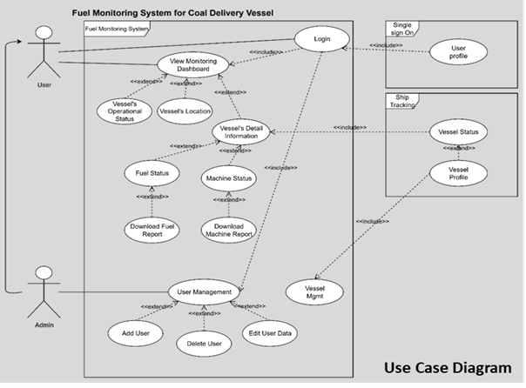  Current Diagram needs additional Nodes for Ship Fuel Prediction and ship ETA | Done
Need to Add Prediction Model | Create ML Service as node in system design using python technologies and LTSM Supervised learning. Expose API using fastAPI | On Progress
Using Random Forrest model as Supervised Learning model Prediction for Fuel and Arrival. Rejected by user | Research on LTSM model for Fuel Prediction and Arrival Prediction | On Progress
Ship route doesn’t reflect to ship arrival. Only routes with strip line and ship symbol | Change Ship route visualization with:  - Traverse line as green line.  - estimated arrival line as dotted grey line | On Progress
Frontend to backend hasn’t linked yet | Start develop backend service.  create unit test case | Pending

  - Current Visualization
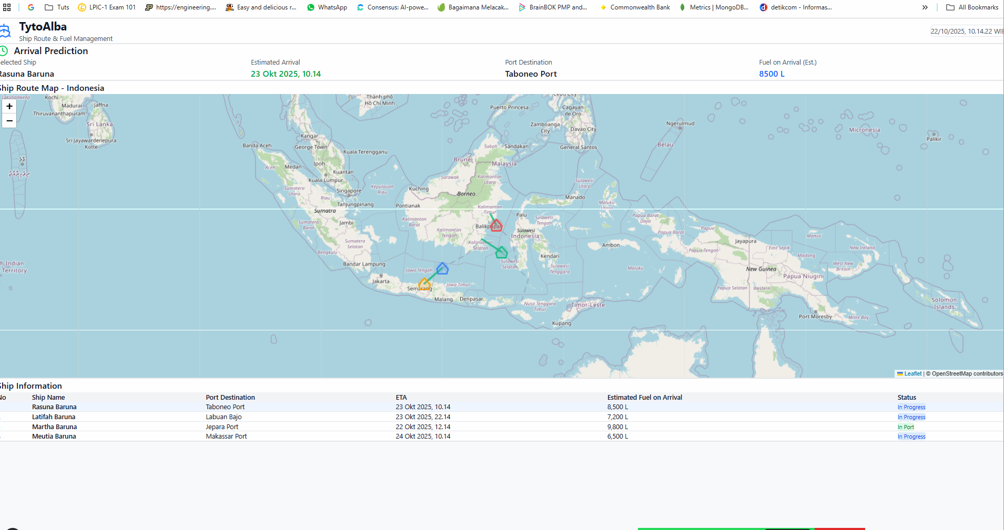

References

5.1 Research Papers
1. **"Deep Learning for Vessel Trajectory Prediction Using Multi-Task Learning"**
- Authors: Kim et al. (2023)
- Journal: Ocean Engineering
- Relevance: Multi-task LSTM for simultaneous ETA and fuel prediction
2. **"Fuel Consumption Prediction for Maritime Vessels Using Recurrent Neural Networks"**
- Authors: Zhang et al. (2022)
- Conference: IEEE ICML
- Relevance: RNN architecture for fuel consumption modeling
3. **"Attention-based Bi-LSTM for Ship Arrival Time Prediction"**
- Authors: Wang et al. (2024)
- Journal: Transportation Research Part E
- Relevance: Attention mechanism for handling variable-length sequences
4. **"Real-time Maritime Monitoring Systems: A Survey"**
- Authors: Lopez et al. (2023)
- Journal: IEEE Access
- Relevance: IoT architecture patterns for maritime applications

5.2 Technical Documentation
- TensorFlow/Keras Documentation for Model building and training
- Vue.js 3 Composition API for Frontend reactive patterns
- Go HTTP Server Best Practices for Backend architecture
- MQTT Protocol Specification for IoT communication standards
- PostgreSQL TimescaleDB for Time-series database optimization

5.3 Industry Standards
- ISO 19848:2018. A Standard for Ships and marine technology. Mainly for shipboard machinery and equipment
- IEC 61162. Maritime navigation and radiocommunication equipment and systems
- IMO MEPC Guidelines. Fuel consumption reporting standards

Appendix
1. Reference Architecture of Predictive ETA and Fuel Consumption
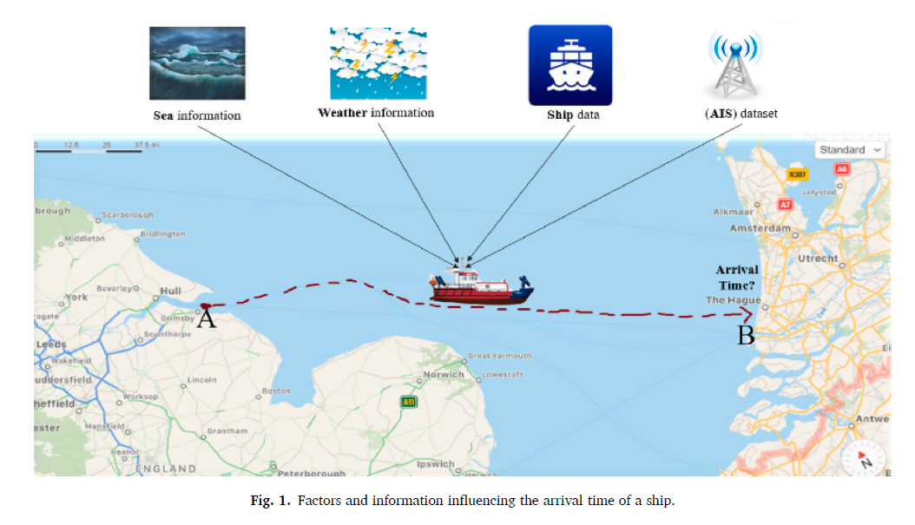
Abdi, A., & Amrit, C. (2024). Enhancing vessel arrival time prediction: A fusion-based deep learning approach. Expert Systems with Applications, 252(PA), 123988. https://doi.org/10.1016/j.eswa.2024.123988

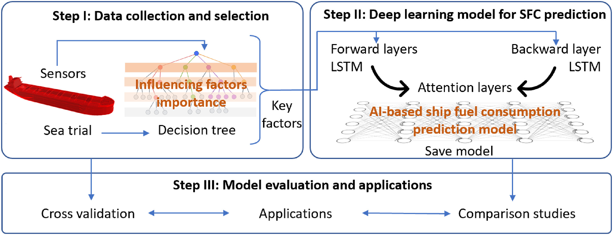
Zhang, M., Tsoulakos, N., Kujala, P., & Hirdaris, S. (2024). A deep learning method for the prediction of ship fuel consumption in real operational conditions. Engineering Applications of Artificial Intelligence, 130(December 2023), 107425. https://doi.org/10.1016/j.engappai.2023.107425

APPENDIX 2 : Timeline
No | List | List Feature |  |  | Estimated Start Month : September 2025
No | List |  |  |  | Sprint 1 |  | Sprint 2 |  | Sprint 3 |  |  | Sprint 4 |  |  | Sprint 5 |  | Sprint 6 |  | Sprint 7 |  | Sprint 8 |  | Sprint 9 |  | Sprint 10
 |  |  |  |  | W1 | W2 | W3 | W4 | W5 | W6 | W7 |  | W8 | W9 |  | W10 | W11 | W12 | W13 | W14 | W15 | W16 | W17 | W18 | W19 | W20
1 | Business Modelling
 |  | 1.1 | Business Modelling | P
 |  |  |  | A
2 | Requirements
 |  | 2.1 | Feature Requirements | P
 |  |  |  | A
 |  | 2.2 | System Requirements | P
 |  |  |  | A
3 | Analysis & Design
 |  | 3.1 | User & Feature Matrix | P
 |  |  |  | A
 |  | 3.2 | Data Table Design | P
 |  |  |  | A
 |  | 3.3 | User Interface (Prototyping) | P
 |  |  |  | A
 |  | 3.4 | Report Design | P
 |  |  |  | A
4 | Development
 |  |  | Central Application System
 |  | 4.1 | Login & Role-based Read-only | P
 |  |  |  | A
 |  | 4.2 | UI Kit | P
 |  |  |  | A
 |  | 4.3 | Fleet Map & Status | P
 |  |  |  | A
 |  | 4.4 | Tank Cards | P
 |  |  |  | A
 |  | 4.5 | 24h/7d Charts | P
 |  |  |  | A
 |  | 4.6 | Alert History (View-only) | P
 |  |  |  | A
 |  | 4.7 | Report Export | P
 |  |  |  | A
 |  | 4.8 | Auto-Refresh & Loading Indicators | P
 |  |  |  | A
 |  | 4.9 | Calibration Curve Overlay (Read-only) | P
 |  |  |  | A
 |  | 4.10 | Port/Route Overlay | P
 |  |  |  | A
 |  | 4.11 | Top-N Vessels | P
 |  |  |  | A
 |  | 4.12 | Speed Prediction Widget (Read-only) | P
 |  |  |  | A
 |  | 4.13 | Dark Mode / PWA | P
 |  |  |  | A
 |  | 4.14 | API Integration | P
 |  |  |  | A
 |  |  | Ship System
 |  | 4.15 | Asset Unique ID, List & Connection | P
 |  |  |  | A
 |  | 4.16 | Asset Unique ID, Tank Information | P
 |  |  |  | A
 |  | 4.17 | Volume Calculation | P
 |  |  |  | A
 |  | 4.18 | TrimmedCalculation | P
 |  |  |  | A
 |  | 4.19 | Payload | P
 |  |  |  | A
5 | Testing
 |  | 5.1 | UAT Environment Preparation | P
 |  |  |  | A
 |  | 5.2 | UAT (User Acceptance Test) | P
 |  |  |  | A
 |  | 5.3 | Documentation | P
 |  |  |  | A
6 | Deployment
 |  | 6.1 | Production Environment Preparation | P
 |  |  |  | A
 |  | 6.2 | Deploy to Production | P
 |  |  |  | A
 |  | 6.3 | Migration Data | P
 |  |  |  | A
 |  | 6.4 | Cut Off and Go-Live | P
 |  |  |  | A
 |  | 6.5 | Sign Off

